**May 15, 2022 - Hate word peak:**

America reaches 1M covid deaths - May 13

**Email Clusters of Interest:**

6, 1, 17, 12, 37

**Email Cluster 6:**

**Title - Policies and donation for affordable medicare for all**

* Equality is non-negotiable campaign (related to healthcare) - donation
* Affordable childcare
* Cost of insulin - voting against lowering it.
* Biden signs PACT act, expanding healthcare for veterans - funds allocation

Dates of peaking - May 30-31*, July 3-4, Sep 11-12

Reasons for date peaks:

May 30, 31 - Wes Moore release comprehensive plan to build a world-class healthcare system for all marylanders

**Email Cluster 1:**

**Title: Roe v. Wade overturned - Right to Abortion**

* Roe v. wade
* Nation-wide abortion ban
* Reproductive rights was fundamental

Dates of peaking - May 2-3, June 23-24*

Reasons for date peaks:

There was a leak of a draft that could potentially overturn abortion right - May 2

U.S Supreme court overturned it on Jun 23.

**Email Cluster 17:**

**Title: US Capitol Attack - Jan 6, 2021**

* January 6, 2021
* Capitol Attack 1 year ago to overturn 2020 elections
* Trump exposed for the planned attack by supporters

Dates of peaking - Jan 6-7

Reasons for date peaks: US Capitol was attacked on Jan 6, 2021 (1 year ago)

**Email Cluster 12:**

**Title: Gun Violence**

* Combat gun violence
* Mass shootings

Dates of peaking - May 24 - May 27

Reasons for date peaks: School shooting on May 24 in Uvalde, TX.

**Email Cluster 37:**

**Title: Ketanji Brown Jackson**

* Ketanji Brown Jackson - first black woman judge

Dates of peaking - Feb 25-26, Apr 5-7*

Reasons for date peaks: Nominated to supreme court on Feb 25 by Joe Biden, voted on Apr 7.

**************************************************************************************************

**Podcast Clusters of Interest:**

85, 77, 11, 109, 57, 1, 25, 5, 15, 6, 30, 55, 27, 82, 3, 4, 70

**Podcast Cluster 85:**

**Title: Historic and religious views**

* Snakes - serpent in your heart, idea of satan
* Bigger Scorpions are less dangerous
* Talks about bible and Gods, christianity

Dates of peaking - May 11 - 13

Reasons for date peaks: Nothing found

**Podcast Cluster 77:**

**Title: Tough-on-crime**

* Policies that improve the US
* Is America great?
* Imprimis - monthly digest on liberty
* California crime - drugs, bad politicians
* Rudy Guiliani - NYC Mayor, cleaned up NYC
* Attack on republican candidate for NY

Dates of peaking - Sep 27- 28 (only 7 instances)

Reasons for date peaks: Trump announces deployment of federal law to cities across the country on Sep 18.

**Podcast Cluster 11:**

**Title: Disney - “Don’t say Gay” Law**

* Walt Disney testifying about infiltrating into american life
* Disney owns the brain of the children exposing them to sexuality
* Leaked footage of disney employee about having secret gay agenda
* Disney stands with LGBTQ opposes the law

Dates of peaking - Mar 29 - 30, Apr 20 -21*

Reasons for date peaks:

Ron DeSantis signed the “Don’t say Gay” law on Mar 28.

Florida passed a bill to repeal a law disney to operate private govt over its properties on Apr 20.

**Podcast Cluster 109: (Doesn’t make a lot of sense)**

**Title: Food items and eating habits**

* Live in pods, eat bugs, work in metaverse
* Getting back from Covid lockdowns
* Eating habits and different food items, intuitive eating
* Oz and Fettermen debate

Dates of peaking - Feb 10 -12, Aug 15 -17 (only 9 instances)

Reasons for date peaks: None found as the discussion topics were too general

**Podcast Cluster 57:**

**Title: Reparations**

* Reparations for slavery
* Healthy eating and working out

Dates of peaking - Mar 21 - 22*, Sep 21 - 22

Reasons for date peaks:

NJ to vote on reparation on Mar 14

Don Melon (CNN host) clip went viral about reparations on Sep 20

**Podcast Cluster 1:**

**Title: Russia Ukraine war**

* Sanction on Russia
* Europe’s reaction
* Gas and Oil pipelines

Dates of peaking - Feb 23 - 26, Mar 1 - 4*

Reasons for date peaks: Russia launches military invasion on Ukraine on Feb 23

**Podcast Cluster 25:**

**Title: Pennsylvania Senate Elections**

* Dr. Oz and John Fetterman debate
* Pennsylvania elections

Dates of peaking - Oct 25 - 28

Reasons for date peaks: The debate was on Oct 25

**Podcast Cluster 5:**

**Title: Twitter Acquisition by Elon Musk**

* Acquire Twitter
* Increase twitter subscriber base and revenue

Dates of peaking - Apr 14 - 15, Apr 26 - 27

Reasons for date peaks: Musk bought Twitter on Apr 14

**Podcast Cluster 15:**

**Title: American Drone Strike in Afghanistan**

* US Drone strike kills Al Qaeda leader Ayman Zawahiri
* Almost 1 year of American troops withdrawn

Dates of peaking - Aug 2 - 3

Reasons for date peaks: US Drone strike kills Al Qaeda leader Amin Zawahiri on Aug 2

**Podcast Cluster 6:**

**Title: China - Olympics and Spies**

* China Olympics
* Biden more pro-china than any president
* War with China
* Chinese spying in the US

Dates of peaking - Feb 3-4*, Aug 4-5

Reasons for date peaks:

China Olympics started on Feb 4

Spies identified to be associated with China - Feb 2

Nancy Pelosi trip to China - Aug 4

**Podcast Cluster 30:**

**Title: Queen Elizabeth II**

* Queen is dead
* Royal Family

Dates of peaking - Sep 8 - 10

Reasons for date peaks: Queen Elizabeth II passed away on Sep 8

**Podcast Cluster 55:**

**Title: FDA Baby Formula Bill**

* Baby Formula shortage
* Supply chain problems
* Abbott Plant (children becoming ill after consuming Abbott’s products)

Dates of peaking - May 8 - 21

Reasons for date peaks: FDA reaches agreement with Abbott Labs to reopen the company on May 17 due to shortage.

**Podcast Cluster 27:**

**Title: Saudi Arabia - USA (Oil)**

* President Joe Biden visit to Saudi Arabia
* Less Oil Production in Saudi relatively
* Saudi Arabia’s 9-11 connections (declassification of documents)

Dates of peaking - July 17 - 18, Oct 13 - 14*

Reasons for date peaks: President visits Saudi Arabia on July 15, 2022.

Saudi cuts its oil production target - Oct 13

**Podcast Cluster 3:**

**Title: Abortion - Roe v. Wade**

Dates of peaking - May 4-5, Jun 27 - 28

Reasons for date peaks:

There was a leak of a draft that could potentially overturn abortion right - May 4

U.S Supreme court overturned it on Jun 23.

**Podcast Cluster 4:**

**Title: Illegal border crossing**

* Borders control
* illegal entry at night, deaths and crimes during the entry
* Border crossing arrests

Dates of peaking - Sep 15 - 16*, Sep 19 - 22

Reasons for date peaks:

News about number of death during border crossing on CNN - Sep 7

Record number of arrest stats released on Sep 20

**Podcast Cluster 70:**

**Title: Florida**

* Florida - no income tax, beautiful place
* Cigar industry in florida
* Leave California and NYC to Florida

Dates of peaking - Jan 30 -31, Aug 8 -9 (not so significant instances-only around 10)

Reasons for date peaks: Too generalized to find evidence

**************************************************************************************************

Similarity Matches

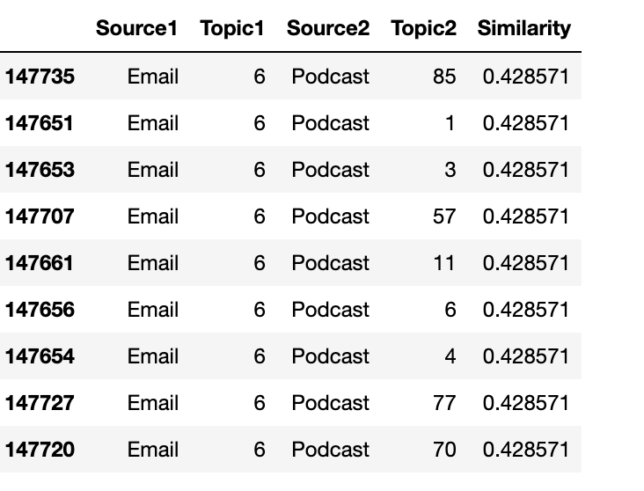

Email cluster 6 (**Policies and donation for affordable medicare for all**) is matched with several podcast clusters:

Podcast cluster 85 - **Historic and religious views**

Podcast cluster 1 - **Russia Ukraine war**

Podcast cluster 3 - **Abortion - Roe v. Wade**

Podcast cluster 57 - **Reparations**

Podcast cluster 11 - **Disney - “Don’t say Gay” Law**

Podcast cluster 6 - **China - Olympics and Spies**

Podcast cluster 4 -  **Illegal border crossing**

Podcast cluster 77 - **Tough-on-crime**

Podcast cluster 70 - **Florida**

**************************************************************************************************

**TV Clusters of Interest:**

72, 24, 17, 32, 9, 84, 68, 108, 19, 6, 136, 111, 22, 101, 45, 143, 154, 152, 27, 88, 10, 212, 269, 115, 138, 14, 23